# Assignment 6 (Hits as time predictor)

In this assignment, I create three class to find the relationship between the instruments and execution time.I created 3 drivers for MergeSort, HeapSort and QuickSort Dual Pivots to get the number of execution time and instruments. All drivers are store in “src/main/java/edu/neu/coe/info6205/util/ ”.

**Screenshot of the three new class:**

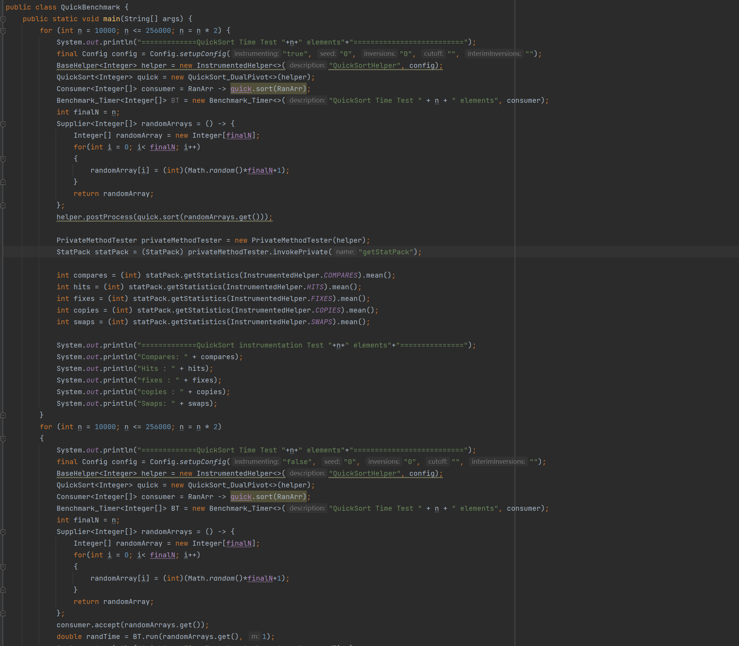

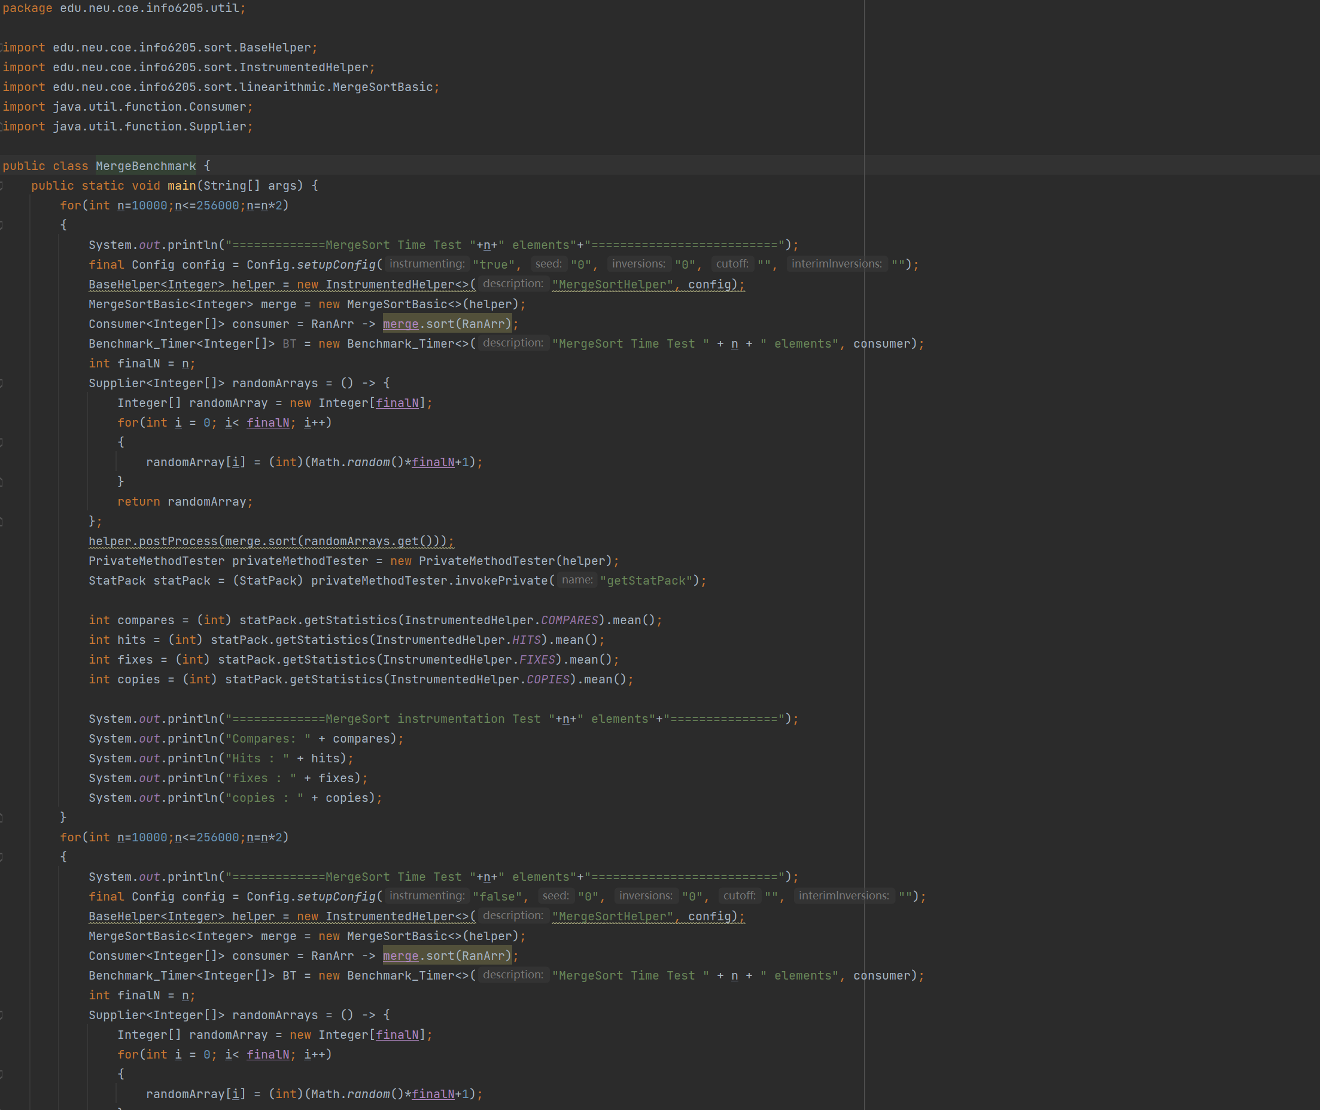

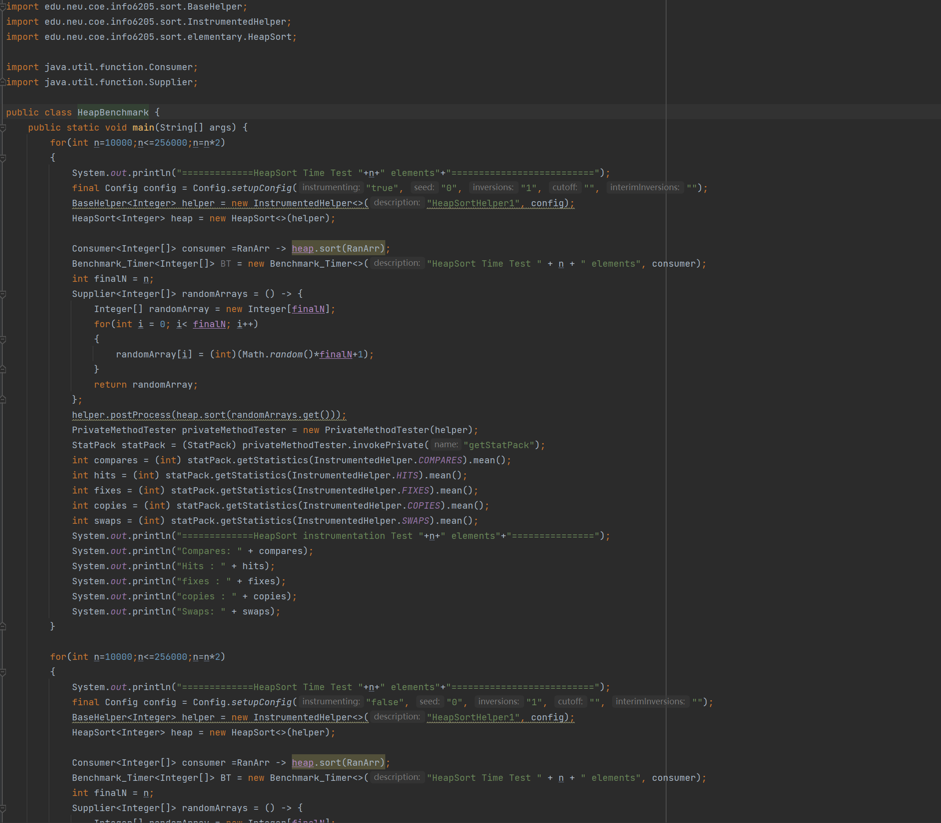

**Screenshot of the Data result:**

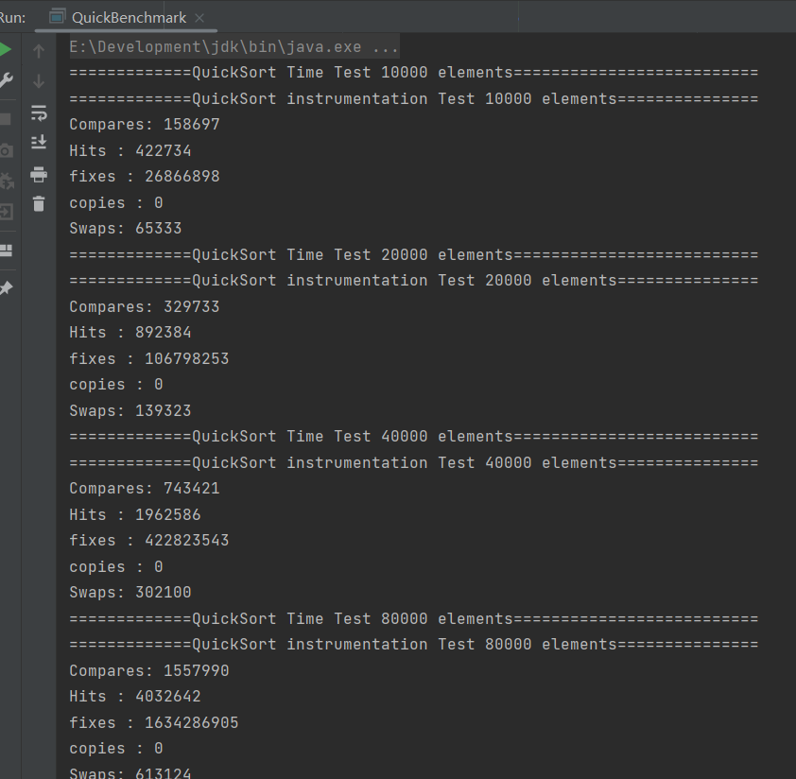

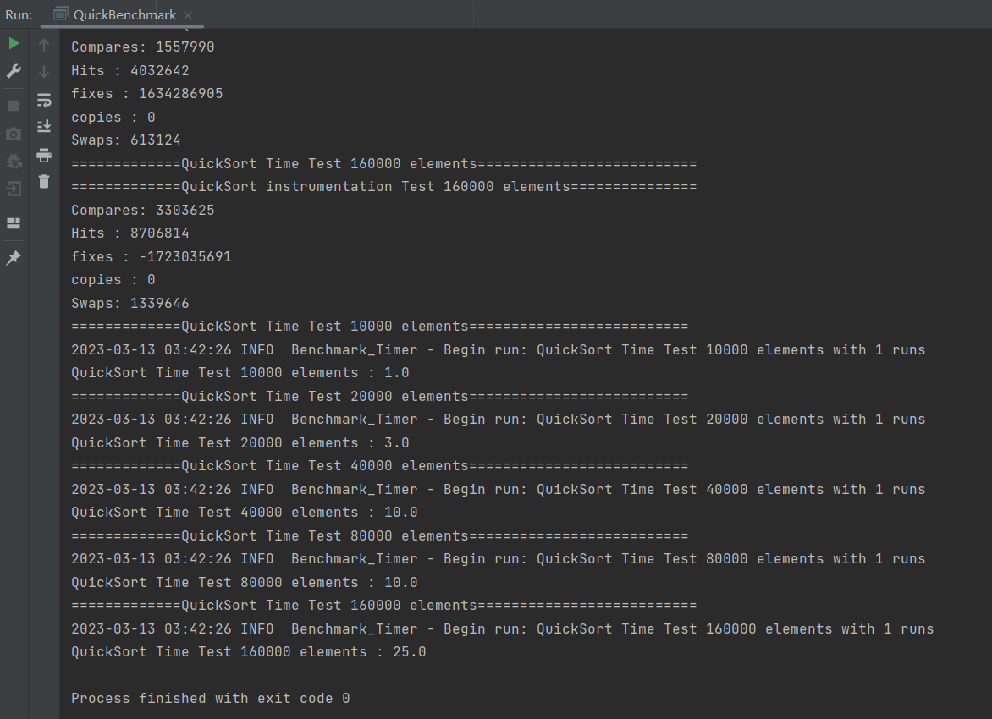

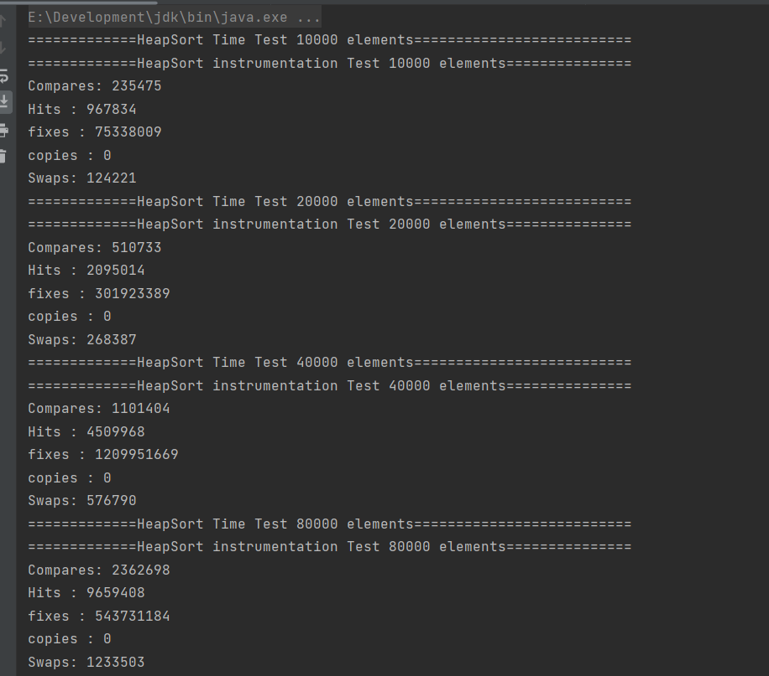

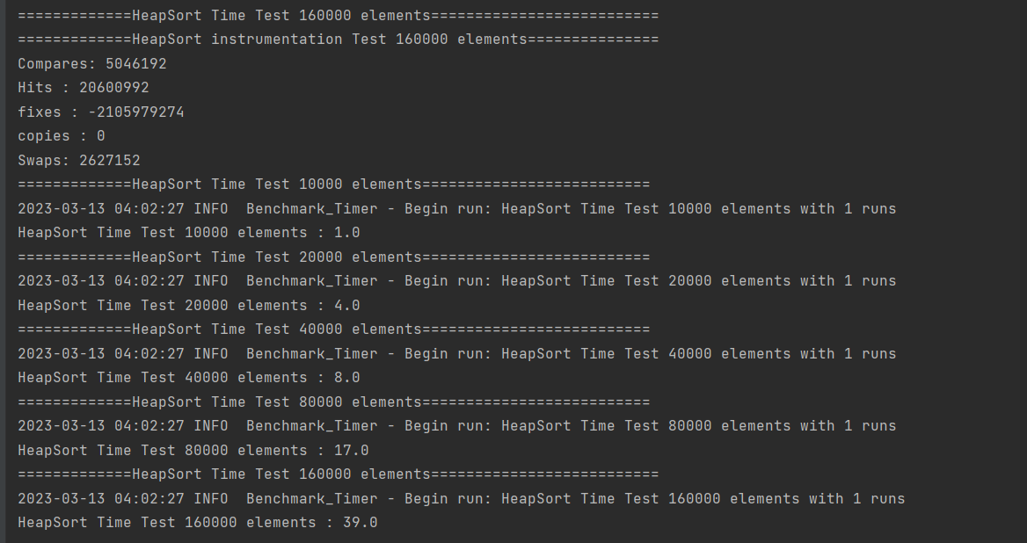

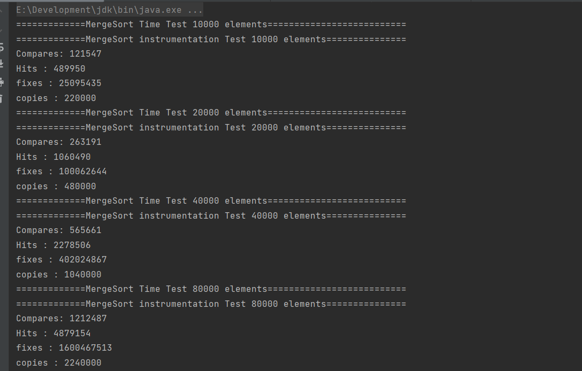

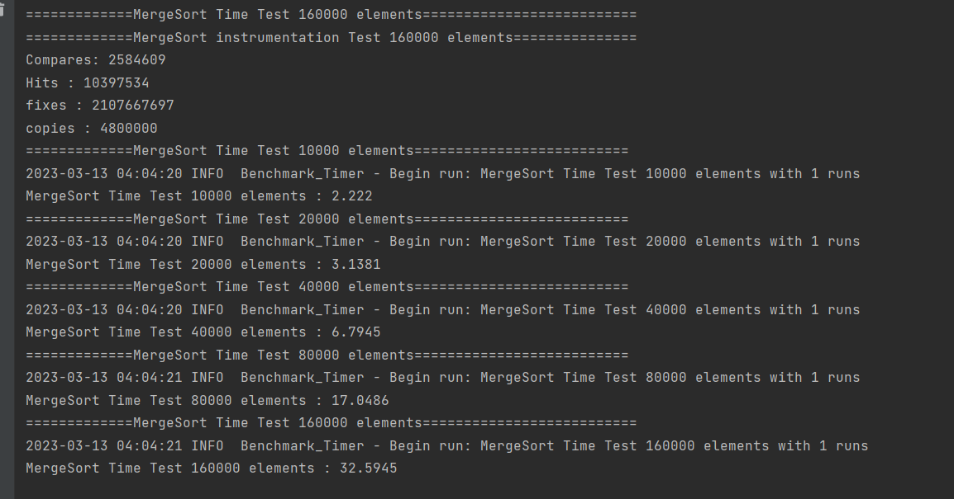

**Screenshot of the Charts:**

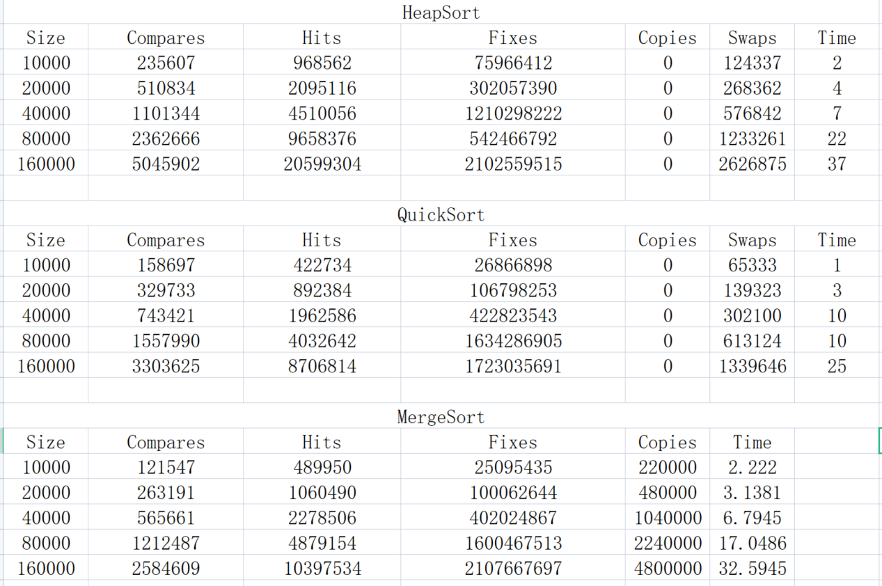

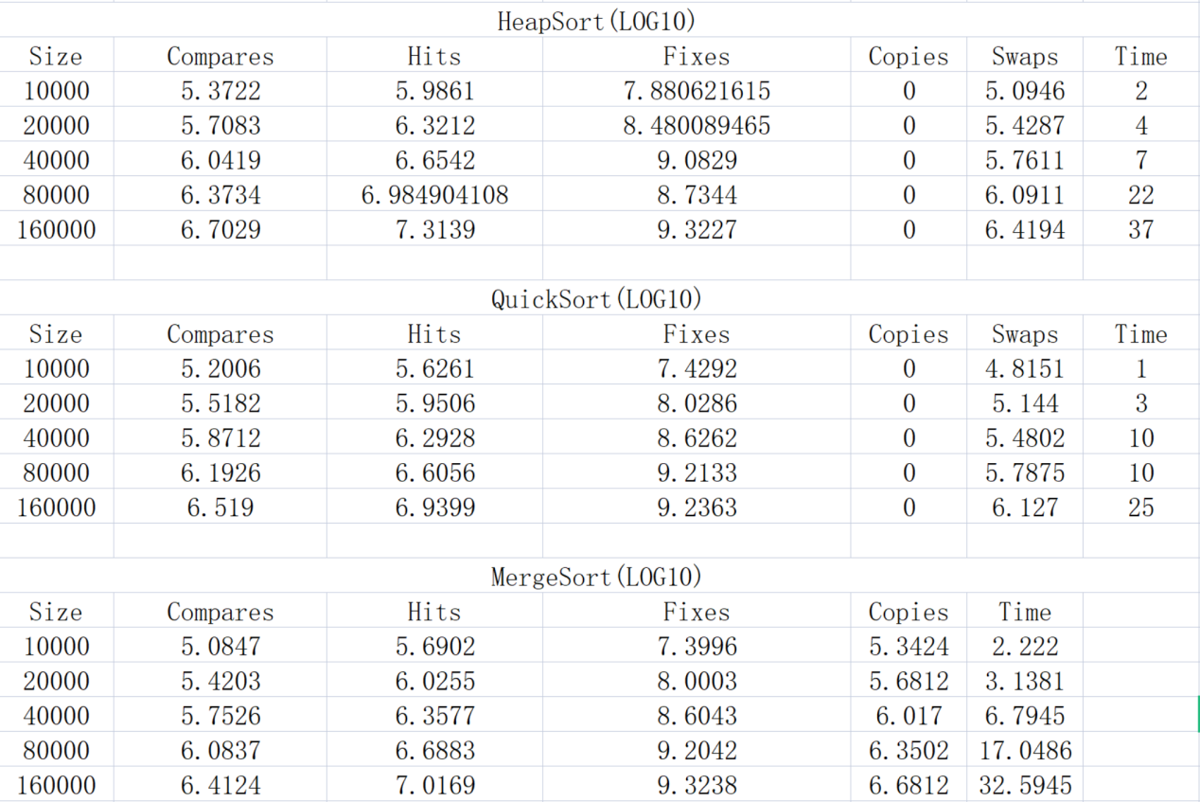

**Conclusion：**

From the analysis of the data, The best predictor for execution time varies for different sorting algorithms. For MergeSort, the data shows that the number of Swaps/Copies fits Execution Time perfectly, which means that the number of Swaps/Copies determines the Time. For QuickSort, the data shows that the number of Compares and Swaps determine the Execution Time. For HeapSort, the data shows the number of Compares and Swaps determine the Execution Time.This indicates that each sorting algorithm may have different aspects that affect their performance. . It can be observed that as the size of the input array increases, the execution time for all three sorting algorithms increases exponentially.5. Quick sort and HeapSort have similar performance in terms of execution time, but HeapSort requires a slightly higher number of swaps and copies compared to QuickSort. This suggests that QuickSort may be a better choice in scenarios where memory usage is a concern. From the given data, it can be concluded that Merge sort is the most efficient algorithm among the three sorting algorithms.